MODULE 3

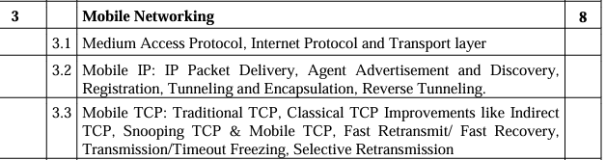

IMPORTANT QUESTIONS:

Q. How is Packet Delivery Achieved to and from mobile nodes

Q. Explain Agent registration process in mobile communication

Q. What is reverse tunnelling

Q. Explain Selective Retransmission process at TCP

Q. Explain Snooping TCP and Mobile TCP with their merits and demerits

-> Medium Access Protocol

-> Mobile IP – Packet Delivery (Tunneling and Encapsulation)

-> TCP

-> Agent Advertisement and Discovery

Q. What is reverse tunnelling – 5M

Q. How is packet delivery achieved to and from mobile nodes? -10M x2

Q. Explain selective retransmission process at TCP – 10M

Q. Explain agent registration process in mobile communication – 10M

Q. Explain packet delivery mechanism “to and from mobile node” with the help of mobile Ip network diagram-10M

Q. Explain tunnelling and encapsulation in brief. What are the various types of encapsulation techniques – 10M

Q. Snooping TCP – short note 5M

Q. Explain Snooping TCP and mobile TCP with their merits and demerits – 10M

Q. Explain the process of registration in Mobile IP – 10M

